Lab Exercise Lab 10
Task#1: Task one create the min max heap from values 8, 7 , 6 ,5 , 4 the tree looks like below:
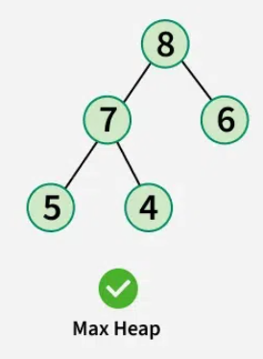
Now change write a function that can take the two parameters one index and other value , after that update that value store at that index i with the values provided in parameters void update_key(int i, int new_val); then delete the element from heap.
Task#2: Look at above tree and write a function to check if a given array represents a Binary Heap? After that sort the array in ascending order
Task#3: Given an integer array arr[] of size n elements and a positive integer K, the task is to return the kth largest element in the given array (not the Kth distinct element).
Examples:
Input: [1, 23, 12, 9, 30, 2, 50], K = 3
Output: 23
Input: [12, 3, 5, 7, 19], K = 2
Output: 12

Task#4: Given an array representation of min Heap, convert it to max Heap.
Examples:
Input: arr[] = {3, 5, 9, 6, 8, 20, 10, 12, 18, 9}
3
/ \
5 9
/ \ / \
6 8 20 10
/ \ /
12 18 9
Output: arr[] = {20, 18, 10, 12, 9, 9, 3, 5, 6, 8}

